

**INVESTIGATION REPORT**

**Online Crowdfunding System**

**By**

**Sujan Shrestha**

**NP000611**

**NP3F2304IT**

A report submitted in partial fulfillment of the requirements of Asia Pacific University of Technology and Innovation for the degree of

B.Sc. (Hons) Information Technology

Supervised by Mr. Bishal Prasad Kurmi

2nd Marker: Mr.Rajan Raj Pant

December 2023

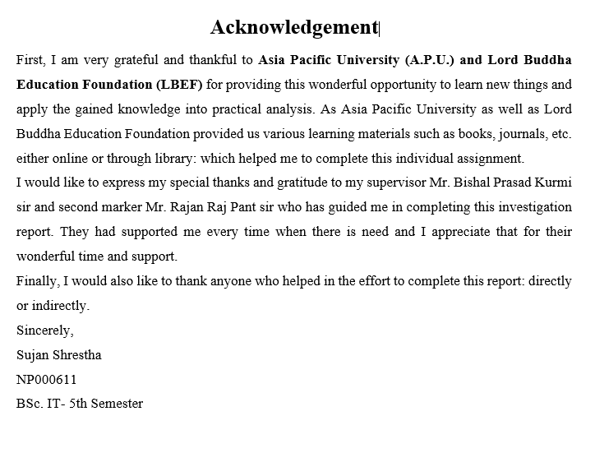

Table of Contents

**1** **Chapter 1: Introduction to the study** 1

**1.1** **Background of the project** 1

**1.2** **Problem Context** 2

**1.3** **Rationale of the Study** 2

**1.4** **Potential Benefits** 3

**1.4.1** **Tangible Benefits** 3

**1.4.2** **Intangible benefits** 3

**1.5** **Target Users** 4

**1.6** **Scope and Objectives** 4

**1.6.1** **Aim** 4

**1.6.2** **Scope** 4

**1.6.3** **Objectives:** 5

**1.6.4** **Deliverables:** 5

**1.7** **Project Plan** 7

**2** **Chapter 2: Literature Review** 9

**2.1** **Introduction** 9

**2.2** **Research Domain** 9

**2.3** **Similar Systems** 15

**3** **Chapter 3 Technical Research** 17

**3.1** **Introduction** 17

**3.2** **Selected Programming Languages** 17

**3.2.1** **Comparison between MEAN Stack and .NET technology** 17

**3.2.2** **Rationale for choosing MEAN Stack** 18

**3.3** **IDE (Interactive Development Environment) Chosen** 19

**3.4** **OS (Operating System Chosen)** 20

**3.5** **Summary** 20

**4** **Chapter 4: System Development Methodology** 21

**4.1** **Introduction** 21

**4.2** **Comparison of System Development Methodology** 21

**4.3** **Selection of Waterfall Methodology as System Development Methodology** 23

**4.3.1** **Waterfall Methodology** 23

**4.4** **Summary** 25

**5** **Chapter 5: Research Methodologies** 27

**5.1** **Importance of Data gathering and Analysis** 27

**5.2** **Research Method Types:** 28

**5.2.1** **Qualitative Research** 28

**5.2.2** **Quantitative Research** 28

**5.2.3** **Mixed Research** 28

**5.3** **Quantitative method as chosen method.** 28

**5.4** **Research Design** 30

**5.5** **Summary** 36

**6** **Chapter 6 Requirement Validation** 36

**6.1** **Analysis of Data** 36

**6.1.1** **Data analysis through questionnaire** 36

**6.2** **Summary** 45

**7** **Consclusion** 45

**8** **References** 46

**9** **Appendices:** 49

**9.1** **Ethics Form:** 49

9.2 Project Proposal Form (PPF) 54

9.3 Project Specification Form (PSF) 69

9.4 Project Log Sheet 92

# **Chapter 1: Introduction to the study**

Through the developing age of technology, every kind of activity and operation has undergone a transformative evolution and evolved with the advent of online mediums to the activities and operations. Everything has moved to the global internet facility which makes things accessible for everyone throughout the globe. During this transformation, the landscape of fundraising and financial support has also taken a major turn with transformative evolution with options of online crowdfunding platforms. A traditional way to raise funds has been challenging to access of so many creators out there, the online crowdfunding platforms have evolved as a dynamic and inclusive alternative, decreasing the hassle of going through traditional way of raising funds for projects and startups.

With the vision to revolutionize the way individuals and organizations can raise capital, this final year project dives into the implementation of hassle-free online crowdfunding platforms which can make the fundraising scenario more dynamic and inclusive. A user-friendly and robust system that facilitates the connection between the backers and project creators in the context of the nation where technology has been advancing more and more would have a great potential to solve a real-life problem for many individuals and organizations. In this sophistical era of innovation, the online crowdfunding platform can act as a economic elevation platform for many individuals and organizations out there wandering with different world changing ideas.

## **Background of the project**

With a vision to empower Nepalese innovators and visionaries, this project aims to establish a dynamic online crowdfunding platform that not only catalyzes the realization of creative ideas but also fosters sustainable startup ventures. By bridging the gap between visionary creators and enthusiastic investors, an online crowdfunding platform sets out to be the catalyst for transforming imaginative concepts into tangible successes.

In a country where budding creators often struggle to find avenues for showcasing their innovative ideas, this crowdfunding platform in Nepal emerges as a beacon of opportunity. It not only provides a stage for presenting groundbreaking concepts but also offers a mechanism to secure essential financial support. Our platform serves as a nexus for synergies between creators and investors, resulting in a harmonious convergence of visionary ideas and capital infusion.

This platform isn't just about funding; it's about empowerment and realization. Creators gain a platform to test their concepts in the market, acquire invaluable feedback, and secure essential funds to propel their ventures forward. Simultaneously, investors gain access to a diverse array of investment opportunities spanning technology, art, design, and beyond, fostering an ecosystem that thrives on innovation and creativity.

## **Problem Context**

Nepal's innovation ecosystem faces a pivotal challenge in the absence of a dedicated platform connecting creators with potential backers. Aspiring entrepreneurs struggle to showcase their inventive ideas, hindering their access to necessary funds. Simultaneously, investors lack a streamlined channel to discover and support promising projects. The conventional funding process is cumbersome, lacking efficiency and accessibility. This disconnect curtails the growth of Nepal's creative economy and hinders the collaboration essential for transformative ventures. Addressing these calls for an intuitive online crowdfunding platform, that bridges this gap, enabling creators to access funds while investors discover and nurture innovation.

Despite being a nation rich with vibrant community of entrepreneurs, social activists, and creative minds, many promising ideas and projects face a common hurdle which is access to adequate funding. These project fails before the start of the innovation as traditional financial mediums in Nepal often have stringent criteria which makes it challenging and difficult for innovations and ideas to secure necessary funds to thrive.

Moreover, the geographical barriers, diversity and dispersed population also poses additional challenges for creators to reach broader audience for raising capital. Many innovative plans and projects struggle to gain visibility beyond their small and immediate surroundings. In this modern era of technology, a good crowd funding platform can help individual creators or organizations to tap into a deep and vast network of investors or potential backers.

## **Rationale of the Study**

The most prioritized reason of the study done on the landscape of fundraising and financial support to projects is to examine the accessibility of an emerging project to its capital. Many innovative and creative projects fail to make it to the market due to lack of funds to raise the scale of production. The only existence of traditional fundraising methods will not be enough to gain the attraction of the wider or boarder audience. A good platform will eventually assist creators to showcase and bring their ideas to the wider audience and market with many investors willing to invest their funds for the development or production of innovative and creative projects. This study attempts to integrate modern technology and tools in the field where there are only traditional methods to gain access to the funds and audience for the creators. Hence, a modern crowdfunding platform for creators to showcase their creativity and investors to back the creators with funds.

## **Potential Benefits**

The implementation of the online crowdfunding platform comes with numerous benefits as it directly implies on the economic status of certain parties. Involved parties can profit with various tangible and intangible benefits such as:

### **Tangible Benefits**

Access to Fund

Creators with effective ideas that can change or disrupt the market can gain valuable access to a wider pool of potential investors which increases the chances of securing the capital needed for their project. This overcomes the traditional channels where only a limited audience can be reached.

Global Recognition

As the platform is of online nature, it can reach the global market or audience eradicating the geographical barriers that can interrupt the visibility of project. The online platforms will provide different sources of funding and foster a more inclusive and supportive base for projects.

Cost Effective Capital

When compared to traditional fundraising techniques, the online crowdfunding platform will have lower overhead costs, making the fundraising process more efficient and maximize the funds to be invested in the project.

### **Intangible benefits**

Validation and Market Testing

A successful campaign on an online crowdfunding platform can provide valuable information regarding the validation of specific project ideas and categories in the market. The platform will help creators to know if their ideas or project can outstand the projects already available in market.

Community Engagement

When available to the global community, the crowdfunding platform helps to create a sensible community around the project with investors being emotionally invested in the success of projects which enhances the project support, long-term engagement and loyalty and helps to build network of passionate investors.

Brand exposure and marketing

With successful campaigns on online crowdfunding platforms, it can generate attention of markets to the project as it will build brand awareness and reputation, attractive attentions from public and potential backers.

Empowerment

These kinds of platforms can help empower individuals and organizations to pursue their goals within the reach of the internet. It will help to democratize the access to funding, by levelling the playing field for diverse projects and creators.

## **Target Users**

The target users for the online crowdfunding platform projects basically includes two kinds of users: Creators and Backer. A creator refers to the users who has certain ideas or creative projects that will be showcased in the crowdfunding platforms to gain attention of the backers or investors. Another target user will be the backer who will have the ability to invest in the ideas or project created by the creators in order to gain valuable rewards where the funding and completion of the project will be the main objectives of both kind of users to be fulfilled. In general, a Creator user type will seek for the fund need for their project to thrive and a backer will view different ideas or projects available in the platform and invest or fund one if the backers like the overall impacts of the project.

## **Scope and Objectives**

A detailed view of the aims, scope and objectives of the project is mentioned below:

### **Aim**

The primary goal of this platform is to establish an inclusive and dynamic online crowdfunding platform that fosters innovation, fuels entrepreneurship, and accelerates the growth of Nepal's creative economy. By providing creators with a dedicated space to showcase their ideas and by connecting them with interested investors, the platform aims to democratize the funding process and propel visionary concepts towards tangible success.

### **Scope**

The system attempts to impact overall economic dynamics of the nation by evaluating and evolving the growth of projects and ideas that can disrupt the global and local market with its introduction. It elevates and encourages both creators and backers to work and create a community with support of each other to elevate their economic status and recognition of projects in the market where a boarder connection of network for both type of users can be beneficial even in the future moves. The platform will establish an inclusive and dynamic online crowdfunding platform that fosters innovation, fuels entrepreneurship, and accelerates the growth of Nepal's creative economy.

### **Objectives:**

Empower Startups: Facilitate startup ventures in Nepal by providing them with a user-friendly platform to present their innovative ideas and secure the necessary funding for launch and growth.

Enhance Access to Funding: Eliminate traditional barriers to funding by offering a streamlined online channel that allows creators to present their projects directly to a wide range of potential backers.

Boost Creativity: Encourage creators to test the market with their ideas by offering a space where they can gather feedback, refine their concepts, and refine their pitches to attract investors.

Connect Creators and Investors: Forge connections between creators and investors from diverse backgrounds, fostering an ecosystem of collaboration and support that enhances the potential for success.

Amplify Entrepreneurial Network: Cultivate a vibrant community where creators, investors, and stakeholders can interact, share insights, and contribute to the collective growth of Nepal's entrepreneurial landscape.

Facilitate Informed Decision-Making: Provide investors with comprehensive project details, enabling them to make informed investment choices based on well-documented business pitches.

Promote Economic Growth: Contribute to the expansion of Nepal's creative economy by nurturing innovation, generating employment opportunities, and fostering a culture of entrepreneurship.

Catalyze Social Impact: Support projects that have the potential to make positive social changes by facilitating funding and exposure, aligning with the broader developmental goals of Nepal.

Encourage Cross-Industry Collaboration: Create a platform that spans various sectors, allowing creators and investors from technology, art, design, and other domains to come together for mutual growth.

Continuous Enhancement: Evolve the platform over time by incorporating user feedback and industry best practices, ensuring that this platform remains a relevant and effective catalyst for innovation and entrepreneurship in Nepal.

### **Deliverables:**

Fully Functional Crowdfunding Platform: Develop and deploy a user-friendly online crowdfunding platform accessible to creators and investors.

User Profiles and Authentication System: Implement a secure user registration and authentication system for creators and investors, ensuring privacy and data protection.

Project Creation Interface: Design an intuitive project creation interface allowing creators to present their ideas, showcase prototypes, and set funding goals.

Project Discovery and Browsing: Develop a user-friendly project browsing and discovery system that allows investors to explore a diverse range of creative ideas.

Project Funding Mechanism: Create a secure and transparent funding mechanism that enables backers to contribute funds to selected projects.

Payment Gateway Integration: Integrate a secure payment gateway to facilitate seamless financial transactions between backers and creators.

Communication and Feedback Tools: Incorporate features such as messaging and comments to enable interaction between creators and backers, fostering engagement and feedback.

Project Rating and Review System: Implement a mechanism for backers to rate and review projects they've supported, providing valuable insights for future investors.

Creator-Backer Connection: Design tools for creators to communicate with their backers, providing updates on project progress and fostering a sense of involvement.

Dashboard and Analytics: Develop personalized dashboards for creators and investors, offering insights into project performance, funding progress, and engagement metrics.

Responsive Design: Ensure the platform is accessible and user-friendly across various devices, including desktops, tablets, and smartphones.

Legal and Documentation: Provide necessary legal documentation and terms of use for creators, backers, and the platform itself.

Testing and Quality Assurance: Conduct rigorous testing to identify and rectify any bugs, glitches, or security vulnerabilities.

Launch and Deployment: Deploy the fully functional platform on a secure server, making it accessible to the public.

By delivering these outputs, the project aims to create a comprehensive crowdfunding platform that caters to the specific needs of Nepal's entrepreneurial and creative communities, fostering innovation, collaboration, and economic growth.

## **Project Plan**

Overall project plan includes the structure of work breakdowns for the preparation and implementation of Investigation report for the final year project.

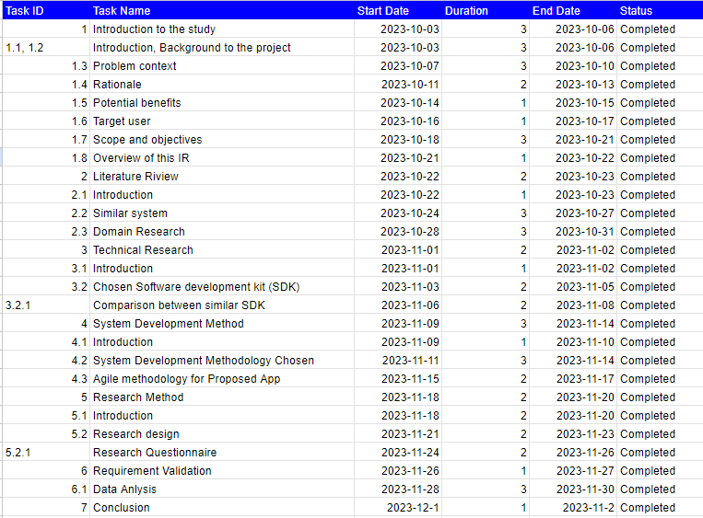

Project plan for Future work

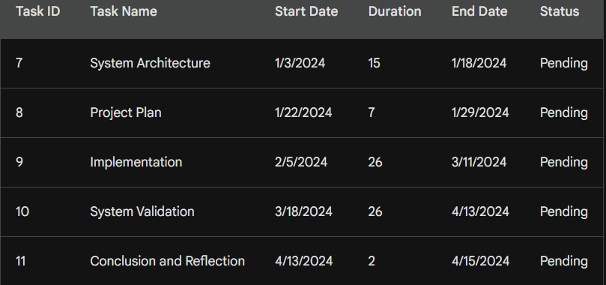

# **Chapter 2: Literature Review**

## **Introduction**

A literature review refers to the process of summarizing, synthesizing, and critiquing the result of a literature search based on the context of primary research project. It is a systematic approach for assessing and summarizing the work of professionals and academics in specific field. It layouts a blueprint by providing summary and examination of prior academic studies related to the concern field and points out any gaps. It provides a detailed account after analyzing and reducing the findings and major ideas from literature search. This will help to guide through the implementation of the project by analyzing the current knowledge areas and provide context or groundwork of the implementation. For the literature review regarding the online crowdfunding platform certain research domains and sources have been examined and summarized below:

## **Research Domain**

1. According to research done by (Althoff, 2015), many crowdfunding platforms which interact over internet allow specific kinds of projects to be funded by targeting large number of people to contribute. With critical analysis of online crowdfunding system such as fundraiser, DonorsChoose.org and others, it is stated that the success of crowdfunding communities depends upon recruitment and continued engagement of donors. With these popular online platforms having donor attrition rate over 70%, the challenge rises due to problem of donor retention for both online and offline crowdfunding platforms. According to research conducted on DonorsChoose.org, it concluded the main problem of these platforms is donor retention as only 26% of the first donors ever return and donate second time.
2. Another research conducted by (Stiver, 2013) states that the relationship between a crowdfunding and online community not only limits to financial terms but many non-financial benefits such as networking, collaboration and feedback. The crowdfunding platform creates a strong community, network and pool of creators and investors whose collective efforts can have huge impact on both social and economic factors of the involved. Online exploration and advertisement with just a few clicks are one of the impactful benefit any organization or starters can get through online crowdfunding platform over the traditional offline method.
3. According to the research done by (Bin Gu, 2019), the new technology and advancements being made in information technology will open more doors of success to platforms like online crowdfunding by enabling new business models and new market mechanisms. Online crowdfunding doesn’t only allow creators to access a place to raise fund, but it also acts as a venue for them to obtain demand information before the production and rethink their intention with the product. There is no doubt that a profit driven entrepreneur earns more than that of product driven entrepreneurs on average, as their advantages is limited by their crowdfunding platforms.
4. Research conducted by (Gabor Kiss, 2014), examined 3169 technology related projects among which 170 projects were successfully funded products which tested different hypothesis regarding crowdfunding platform aiming to find the degree of significance of received funds, total investors, and number of pre-sales. The research concludes that the projects which were categorized under the technology category had received higher number of fundings which generally costs high during product development. The research also showed that reward-based online crowdfunding platforms attracted high number of investors on average while compared to other type of online crowdfunding platforms when examined over technology-based products.
5. Similar to the above research, in the research done by (Winarno, 2018), it is stated that any business regardless the size whether it is micro, small or medium can involve in online campaign for crowdfunding as long as they are familiar with the differences between the crowdfunding modes. The success of crowdfunding heavily depends upon its funding target, total number of backers and sum of investment, which is gradually higher in equity-based crowdfunding on average according to this research.
6. Rachel E. Wheat and Jai Ranganathan describe the dynamics of a success of a crowdfunding project depending heavily upon a successful outreach campaign. The success comes from successful outreach campaigns where the larger crowds refer to more money raised. Various online platforms such as social media platforms and advertisements can easily reach out and channel these investors directly to a proposal online. They have also stated that there is a common myth that these sorts of crowdfunding platforms are only for charismatic projects. But, according to Rachel E. Wheat and Jai Ranganathan, this assumption is completely wrong as the name of the project doesn’t attract investors, the ability or chance of the project being successful does (E & Wheat, 2013).
7. According to the research conducted by (Xiaochen Liu, 2022), product sampling can be considered a great way to test the efficiency and scalability of the product in Reward-based crowdfunding. Online product sampling has been gaining popularity as an effective way of promoting instruments for the creators in fund raising platforms. The idea of online product sampling in a Reward-based crowdfunding also eliminates the problem of uncertainty in outcome of the funding which hinders online transaction among the investors and creators. The analysis was done upon a unique dataset of total of 4027 campaign observations which was collected from a well-known JD crowdfunding platform. The outcome of this research states that adopting the technique of online product sampling is highly beneficial to crowdfunding websites as it increases the number of potential backers, total number of fundraising amounts, total average amount of funds raised per investors, and mainly the possibility of success of fundraising campaign.
8. With objective to collect further information on the working dynamics of the crowdfunding platforms, Goran Calic and Jialiang Yang researched on the topic of “How multimedia shapes the crowdfunding outcomes” by observing 13,622 technology campaign on one of the most known crowdfunding platform “Kickstarter”. The outcomes of this research come positive as the implementation of different multimedia such as images, videos of products tend to generate a greater number of potential backers. The implementation of multimedia increases crowdfunding performance but also on the negative side, it weakens the positive impact of lengthy description on fundraising performance of technology campaigns. The redundant use of media can negatively impact on potential backers as the study suggests (Jialiang Yang, 2020).
9. According to the research conducted by (Stanko, 2017), the total amount of raised during the funding campaign in crowdfunding platform does not have a significant impact on later performance of the product on the market but the total number of potential backers attracted effects the later performance of products. The backer during a crowdfunding campaign plays a vital role in the performance of product in an actual market. They are the earliest possible adopters, who are even more valuable in some cases than that of early adopting customers. This output is generated by analyzing the data of crowdfunded projects from the Kickstarter website to better understand the effects of crowdfunding elements in the subsequent market.
10. Research conducted by (Eunjun Jung, 2022), the novelty of a project or the product directly affect the crowdfunding campaign’s success. This research used a deep learning-based novelty detection model combined with statistical data is used to analyze 7406 crowdfunding. The result supports the hypothesis proposed by the researcher as the output reveals that the novelty of the product increases and attracts numbers of potential backers and project’s success. Two-sided communication in crowdfunding platform helps to stimulate investor.
11. Elizabeth M. Gerber, Julie S. Hui, Pei-Yi Kuo from Norwestern University conducted research which included analyzation of survey regarding Why People Are Motivated to Post and Fund Projects on Crowdfunding Platforms. The result of analyzation was depicted as A funder considers whether to fund a project on Kickstarter, a crowdfunding platform. Initial findings suggest that people are motivated to launch and fund projects on computer-mediated crowdfunding platforms because of social interactions and feelings of connectedness to a community with similar interests (Elizabeth M. Gerber, 2010)
12. According to research conducted by Peter Konhausner, Bing Shang and Dan Dabija relating to the growth of online crowdfunding platforms in Comparative Perspective of Germany and China, the result of the research came in as the growth of the online crowdfunding volume has become one of the fastest types of global financial innovation. Crowdfunding is not only used for raising monetary funds, but also as an instrument for implementing the marketing strategy of an organization. In different countries and regions, crowdfunding project owners have adopted several practical marketing tactics based on their business models and strategic objectives, like online webinars, social media marketing, and offline events (Peter Konhausner, 2021).
13. Jascha-Alexander Koch organized research on the Phenomenon of Project Overfunding on Online Crowdfunding Platforms and analyzed the drivers of overfunding and found out in reward-based crowdfunding, massive overfunding can lead to severe problems for project founders when vast amounts of rewards have to be delivered. Some people even argue that the amount of money that leads to overfunding should be pledged to good but undervalued projects that fail to reach their funding goal. However, it is also a powerful mean to generate publicity and to sell products (Koch, 2016).
14. In 2016, Michael Siering along with Jascha-Alexander Koch worked together on research titled “Crowdfunding Success Factors: The Characteristics of Successfully Funded Projects on Crowdfunding Platforms”. The research had some definitive implications as it depicts “Analyzing a sample of projects of the crowdfunding platform Kickstarter, we find that the project description, related images and videos as well as the question of whether the founder has previously backed other projects influence funding success. Interestingly, the question of whether the founder has previously created other projects has no significant influence. Our results are of high interest for the stakeholders on crowdfunding platforms. (Michael Siering, 2016)”
15. [Endrit Kromidha](https://ieeexplore.ieee.org/author/37085806575) conducted a research analysis on comparative analysis of online crowdfunding platforms where she generally analyzed different platforms from USA, Europe and Asia and found out that regardless of a degree of system standardization, smaller online crowdfunding platforms can impose themselves as obligatory passage points locally and regionally by providing more differentiated services compared to standard best-practices like Kickstarter, taking into consideration the specific needs and characteristics of the communities and regions where they are based. An important indicator suggested by this study to evaluate online crowdfunding platforms and networks is the funding ratio (average sum of pledges per fundraising goal). Subject to future research, fundraisers, funders and other stakeholders are encouraged to consider carefully not only the fees and features of each crowdfunding platform, but also the degree of fitness in terms of system interface, projects and associated crowds using them (Kromidha, 2015).
16. According to the research conducted by [Gloria Gómez-Diago](https://link.springer.com/chapter/10.1007/978-1-4471-6681-8_10#auth-Gloria-G_mez_Diago) on the base of communication of crowdfunding online platforms, she summed up This revolution has utterance at different contexts of the citizens’ lives. Searching for a job, being in touch with people who are far away, being informed about issues of interest, streaming videos, listening to music, buying and or reading books and cocreating documents are all activities now performed online by most of the 40 % of the world population who have internet connection. Collective creation can be done with ease on the cyberspace by using any of the multitude of devices and options available to revolutionize fund raising (Gómez-Diago, 2015).
17. In 2020, [Kabil Nageswarakurukkal](https://www.tandfonline.com/author/Nageswarakurukkal%2C+Kabil), [Paulo Gonçalves](https://www.tandfonline.com/author/Gon%C3%A7alves%2C+Paulo), [Mohammad Moshtari](https://www.tandfonline.com/author/Moshtari%2C+Mohammad) together conducted research on Improving Fundraising Efficiency in Small and Medium Sized Non-profit Organizations Using Online Solutions. Their research depicts the benefits that can be raised from implementing modern online fund-raising platform over the traditional fund-raising techniques where some key benefits were global reach and recognition along with mass connectivity (Kabil Nageswarakurukkal, 2018).
18. According to [Gongbing Bi,](https://www.emerald.com/insight/search?q=Gongbing%20Bi)[Qinghua Xiang,](https://www.emerald.com/insight/search?q=Qinghua%20Xiang)[Botao Geng,](https://www.emerald.com/insight/search?q=Botao%20Geng)[Qiong Xia](https://www.emerald.com/insight/search?q=Qiong%20Xia), they found out In the basic model, when the product quality level is exogenous, the optimal price increases in the product quality level and decreases in the difficulty level of the project, while the corresponding expected profit is a unimodal function of the product quality level and the difficulty level. In the endogenous case, the optimal price is exactly twice the unit cost. With the influence of platforms, platforms with higher CS tend to help the creator to lower the prices and to achieve higher profitability. Moreover, platforms with higher CS usually help the creator to offer higher quality products and to charge higher prices after conducting research on Decision strategies in reward-based crowdfunding: the role of crowdfunding platforms (Gongbing Bi, 2019).
19. Chris Richter b, Alexander Brem c, Cheng-Feng Cheng d, Man-Ling Chang conducted research on Strategies for reward-based crowdfunding campaigns where they found out Practical implications of crowdfunding strategies are derived, and are dependent on the required sales effort and the project added value. The terms communicator, networker and self-runner are important for crowdfunding strategy in order to allow entrepreneurs to extract best practice for increasing the probability of successful crowdfunding projects (Alexander Brem c, 2016).
20. Wheat, Wang, Byrned and Ranganathan describe the video as the most important part of the funding appeal to potential project backers. Videos should touch the heart of backers and tell a real story about the own project. Mollick identifies the lack of a video as extremely negative, stating how “producing a video is a clear signal of at least minimum preparation”. They make another important point: the video is an opportunity to introduce the project owner or team. They describe how backers recognizing a project owner in the video have no positive influence on the project's success. They found out that a personal, emotional relationship between the project owner and the backers is not positively related to the investment in a crowdfunding project (Rachel E. Wheat, 2012).

## **Similar Systems**

1. Kickstarter (International):

Kickstarter is among the most well-known platforms for crowdfunding in the world. It allows creators to share their original work to a large audience, covering everything from art and design to technology and cinema. Backers may contribute money to projects in return for perks or early access to the project. If the endeavor meets its financing objective within a particular period of time, the money is collected, and the project moves forward. Kickstarter's user-friendly interface and various project categories have made it a favorite among entrepreneurs looking for financial help (Jensen, 2018).

2. Indiegogo (International):

Indiegogo is another renowned global fundraising platform which promotes a variety of projects ranging from innovations in technology to helping others. It provides numerous funding options, enabling initiatives to obtain monies even if they fall short of their entire funding goal. Indiegogo additionally provides designers opportunities to interact with supporters, offer prototypes, and give feedback. Its adaptability and global accessibility render it an appealing alternative for creators seeking funding for a variety of projects (Gallemore, 2019).

3. Seedrs (International):

Seedrs is an online service for stock-based fundraising which enables anyone to participate in ventures and early stages businesses as a substitute for equity shares. Seedrs, unlike other fundraising sites, allow supporters to turn into investors and potentially obtain financial ownership in the businesses they support. This concept develops a stronger bond between supporters and creators and matches their goals (Coakley, 2022).

4. GoFundMe (International):

GoFundMe is a renowned worldwide crowdfunding platform that primarily focuses on private raising for a variety of needs such as healthcare expenses, schooling fees, and other emergencies. It enables people to organize initiatives for either themselves or others, offering a forum for groups to unite around people suffering difficulties. The emphasis through individual stories and issues on GoFundMe has led to its popularity (Zhang, 2021).

5. Patreon

Patreon, founded in 2013, is a cutting-edge website that is changing how content producers receive funding by viewers. Patreon, which operates on a subscription basis, allows writers, musicians, and innovators from a variety all industries to earn regulate, regular money donations by their patrons. Patreon, as opposed to conventional crowdfunding, provides a continuous source of revenue through regular contributions, building a long-term and close connection between creators and their fans. Patrons receive unique content, advantages, and closer connections with those whose work they love in exchange for their financial backing. Patreon has played a significant role in enabling independent creators to monetize their work and establish a community around their creative efforts (Regner, 2021).

In Nepal, the absence of dedicated crowdfunding platforms tailored to local needs is apparent. Unlike international markets, there is no central platform that allows creators and entrepreneurs to showcase their ideas and access essential funds. This gap hinders innovation, restricts exposure for creative projects, and impedes the growth of startups. The lack of such platforms limits the collaborative ecosystem necessary for success and stifles Nepal's entrepreneurial potential.

# **Chapter 3 Technical Research**

## **Introduction**

Technical research relates to upgrading or improvisation of technological knowledge regarding the technical aspects of the project. Technical research provides guidance for right selection of technical aspects required by the project itself. All the necessary technical stuff like required SDKs, Programming languages, Database system, hosting platforms comes under this platform. Through technical research, I have explored the different sectors of my project and decided what kind of technology is required by my project.

## **Selected Programming Languages**

As the online crowdfunding platform is a web-based platform which will be hosted upon servers for users to interact with it efficiently through their browsers. I have decided to go for a MEAN stack selection which is a combination of multiple programming languages and techniques that provides full stack service for web development. The MEAN stack contains Mongo DB as a database, Express Js as a backend tool, Node JS as a server-side execution framework and Angular as the frontend tool. This stack is used by different professionals as it is highly efficient for web development. Overall programming techniques will include HTML, CSS, JavaScript, Typescript and different libraries and frameworks of mentioned programming languages.

I have selected MEAN Stack as it exceeded the overall comparison with the .Net Core technology in the field of web development.

### **Comparison between MEAN Stack and .NET technology**

|  |  |  |
| --- | --- | --- |
| Title | MEAN Stack | .NET |
| Stack comparison | Unified JS stack throughout the whole development process | Involves C# for server side development and use combination of HTML, CSS and JS for Front End |
| Flexibility and Simplicity | Very flexible and suitable for small and medium sized projects and startups | Extensive set of tools make it suitable for heavyweight projects. |
| Open Source and Community Support | Components of MEAN stack are open source and backed by active community of contributors. | Some parts of the .NET ecosystem are open source but there is a large community |
| Scalability and Performance | Non-blocking and event driven architecture makes Node JS highly scalable | More complex than node JS in certain scenarios but highly scalable |
| Cross platform compatibility | Runs on multiple cross platforms | Also is a cross platform technology but some legacy features are tied to Windows |
| Database | Uses NoSQL database called MongoDB which has high flexibility in handling diverse data types. | Often associated with SQL server, a relational database |

### **Rationale for choosing MEAN Stack**

Full JavaScript Stack:

All the different components of MEAN Stack use JavaScript or TypeScript which allows for a unified language across different developing scenarios.

Real Time Capabilities:

The service side handler, i.e. Node JS one of the key components of MEAN stack excels in handling real-time applications and it is a important functionality to have in online crowdfunding system.

NoSQL Database:

A NoSQL database is used in MEAN stack which provides flexible, scalable and JSON-like structure of document which excels in handling diverse data types.

Dynamic Front-end Framework:

The MEAN stack has Angular as main Front-end tool which offers robust and modular structure for building dynamic and user-friendly interfaces.

Scalability and performance:

The features of Node JS like asynchronous, event driven nature enables high scalability and can handle concurrent connections and streamline the process of development, reduce context-switching, and improves the performance of system.

## **IDE (Interactive Development Environment) Chosen**

In order to make the development process seamless, optimizing with the best available IDE is a must. There are lots of Interactive Development Environment available globally for development of websites like crowdfunding platforms. As Visual Studio Code comes in as one of the most popular and famous IDEs that supports wide tons of programming languages, tools and techniques. The crowdfunding platform itself will be created or developed using Visual Studio Code.

Visual Studio Code (VS code)

Selection of Visual Studio Code as the preferred IDE for the development of this crowdfunding platform especially when the website is being developed using a MEAN stack is very beneficial. Here are some key reasons to select Visual Studio Code over other IDEs available:

Lightweight and Fast

Visual Studio Code is a well-known IDE for its performance and efficiency as it is very lightweight and provides a responsive and efficient development environment. Therefore, quick iterations and responsive changes in crowdfunding websites can be done efficiently.

Cross Platform compatibility:

VS code is available for multiple platforms like windows, macOS and Linux which allows developers to work through different OS and have consistent development experience.

Extensibility

The rich ecosystem provided by VS Code is unmatched by any other IDEs available currently as there are numerous extensions related to JavaScript, TypeScript, MongoDB, Node JS which will enable developers to enhance the productivity and streamline workflow.

Integrated Version Control:

A built-in integration of Git interface makes it easy to manage version control directly from VS Code itself. This is essential for tracking changes and resolving conflicts.

Powerful Debugging:

There are tons of debugging features for Node JS applications in VS code which are robust and supports breakpoints. Inspections and accelerate the troubleshooting process.

Integrated Terminals:

VS code has the feature of integrated terminal allowing programmers to execute different commands and scripts without leaving the IDE.

These are among the features or reasons that make VS code a very suitable IDE for development of Online Crowdfunding System.

## **OS (Operating System Chosen)**

The OS is an integral part of computing as it regulates the complete I/O process and other resources in operations. The most popular OS available in today’s era are MacOS, Windows and Linux where Windows tends to provide more flexibility and simplicity in communicating with the developers. The support for wide range of application and technical tools is provided by windows which depicts the major reason for Windows latest Operating System to be chosen as the preferred Operating System for this project,

## **Summary**

In summary, the crowdfunding system will be developed with the use of Visual Studio Code IDE. The development will be done using MEAN stack where JavaScript will be the main programming language along with the user of Typescript. Different frameworks such as Angular and Bootstrap will be also used to enhance the development process of this Online Crowdfunding System. The backend part will be handled through the user of Next Js and the server-side handling will be done through Node JS. Coming to the part of database, A NoSQL database i.e. MongoDB will be used, and the development process will be done with the use of Windows Operating System.

# **Chapter 4:** **System Development Methodology**

## **Introduction**

A standard process mapped in an organization in order to implement all the necessary steps to analyze, design, develop, implement and maintain an Information System. It is a methodology that helps to systematically organize the best methods and mediums to develop and implement a system. This includes a description of minute processes that needs to be addressed during the development and implementation process of system. Different sorts of activities such as planning, examining, analyzing the system is showcased in system development methodologies. These methodologies tend to enhance the efficiency of the system itself. There are different kinds of System Development Methodologies such as Agile methodology, Spiral methodology, Waterfall methodology, Rapid Application Development methodology, Extreme Programming and so on.

## **Comparison of System Development Methodology**

Here, a comparison among three different system development methodologies are shown below:

|  |  |
| --- | --- |
| Methodologies | Overview |
| Waterfall Methodology | Sequential Process:  A linear and sequential process is followed by waterfall model which asserts that certain remaining task must be completed before moving on to the next task making it easy to understand and manage works.  Rigidity:  It is challenging to accommodate to a change once a certain phase is marked completed. Therefore, this methodology is suitable for projects with well-defined scope and requirements.  Detailed Documentation:  This methodology emphasizes on extensive document as each phase which makes the understanding of progress of project more concise and detailed. |
| Agile Methodology | Iterative and Incremental:  This methodology provides adaptable approach to change in requirements according to frequesnt client feedbacks as it emphasized iterative development with small and incremental changes.  Collaborative and Adaptive  Well suited for projects containing multipke teams as it encourages collaboration among the cross functional and technical teams and can handle changes even in later phases.  Involvement of User:  In order to align the product deliverables with the customer requirements, customers are encourage to take participation during entire development process. |
| DevOps Methodology | Development and Operations integration  This methodology aims to automate processes by reducing deployment duration via collaboration of development and operational teams.  Continuous Integration with Continuous Development:  It’s all about enhancement in quality and schedule of deployment times through continuous emphasis on automation of building, testing and deploying codes.  Collaboration and Communication:  Decrement of silos and enhancement of efficiency of project through strong team collaboration and communication |

## **Selection of Waterfall Methodology as System Development Methodology**

After analyzing the requirements and nature of Online Crowdfunding platform project, along with the comparison among the above three suitable methods, the preferred methodology or this project is selected to be Waterfall Methodology as it aligns with the nature of the project. Selection of this methodology will be beneficial over the selection of other methodology as it depicts the behavior required for the development of the project. Both Agile and DevOps methodologies would have higher impact if the project of Online Crowdfunding System had involved multiple teams working on it. But as the project is being developed with minimal human resource, Waterfall methodology will be more suitable for this project.

### **Waterfall Methodology**

Waterfall Methodology refers to a sequential development methodology which as the name suggests flows like a waterfall through different phases of the project. These phases may include analyzation, design, development and testing along with others where one phase will be wrapped up to move to the upcoming phase. It is said that the Waterfall Methodology suits the projects which have clear requirements as it follows the adage of “measure twice, cut once”. The amount and quality of work done in each phase are believed to be two major reasons for successful implementation of this methodology. The Waterfall methodology provides more accurate estimation of schedule and depicts great time management as the majority if the research is done during the initiation stage of the implementation.

#### **Reason to Choose Waterfall Methodology upon other Methodology for this Online Crowdfunding system are explained below:**

Clear Requirements

The waterfall methodology is said to be effective when a project has a well-defined and clear requirement from the initial stage. This is due to the reason that the methodology follows a sequential process where initiation of each later phase depends upon the completion of the previous phase.

Predictable Timeline:

This methodology defines a structure and predictable timeline which assists in planning and management of system or project in later stages. This will help developers to create a clear roadmap of the project.

Comprehensive Documentation:

Waterfall methodology produces a comprehensive document of the project which can be very beneficial for the future reference, audits, or compliance requirements as it emphasizes strongly on documentation of each stage of the project.

Less Complex Project Management

It is less complex in terms of management of project as compared to other methodologies like Agile which consist for frequent iterations and integrations. This can be very beneficial to projects which have well-defined requirements from the beginning.

Limited Involvement of Clients

Waterfall methodology is suitable for projects which require very little amount of client involvement during the design and development process of the project. The client inputs are considered during the initial stages of the project where they are analyzed to generate clear scope and requirements of project. This will help to reduce the occurrence of major changes during the development phase of the project.

#### **Different Phases of Waterfall Methodology**

Requirement Gathering and Analysis

In the initial phase of the waterfall methodology, requirement gathering, and analysis is taken into consideration through stakeholder interactions. The major goal of this phase is to identify the explicit and implicit requirements, collect views on the required features, preferences and functionality to be involved in the overall system. This phase helps to prevent costly modifications in later development phases by ensuring precision and detailed requirements gathering ultimately leading to well-structured blueprint of the system from beginning.

Design Phase

The design phase in the Waterfall Methodology is implemented for creation of a comprehensive system blueprint which consists of user interfaces, structure of data and architecture of system to be developed. Various parties involved in the project collaborated to make decisions regarding the design and implementation of data flows and architecture for efficient data management and development of the system. In this stage, creation of User Interfaces through wireframes and other designing techniques are done to design significant norms for an organized approach to software development.

Implementation Phase

This phase generally refers to development w=phase where the coding step is done through involvement of translating specifications of the design into a working code through programming, assembling and compiling. The conceptual designs are converted into executable systems through coding. The conversion from the design and wireframes of the system into machine readable instructions is done through compilation and create an operational software system.

Testing Phase

After the software development process, the waterfall methodology moves on to the testing phase which involves extensive testing to identify bugs or any lacking in the functionality, readability and efficiency of the system that is developed. Different kinds of testing such as unit testing, integration testing and system testing are done to verify the developed system meets the requirements of the user. The ultimate objective of this stage is to identify and eradicate the anomalies or deviations from intended functionality, ensuring the system is ready to be deployed.

Deployment Phase

This phase in waterfall methodology aims to produce a final product to the user or customer, which involves the installation, setup, and operationalization. In this phase, user needs are set up though customization, correct configuration is ensured through installation, and operation fixes problems and provides informed information and instruction regarding the operation of system. Once the system is deployed, the waterfall model is ready to move on to the maintenance phase ensuring the system produces values and aligns with the user expectation and standards.

Maintenance phase

The maintenance phase in the waterfall methodology focusses on regular system checkups, updates and dependencies update. This phase tends to accept any issues or bugs reported by the users in order to facilitate effective interaction with users and development team. Any kind of issues and bugs are fixed and solved promptly to bring stabilization and seamless operation of the system. The maintenance activity is influenced heavily through the feedback received from the end users.

## **Summary**

With comparison to Agile and DevOps methodologies, the waterfall techniques stand out as an suitable techniques or methodology for the project of online crowdfunding system as it is logical and continuous process that contains distinct and diverse phases throughout the project life cycle. Different features such as its rigorous, methodical approach contrast the overall iteration and flexibility aspects when compared to other methodologies. Because it sticks to the project's scope and provides precision and clarity in each step of development, the Waterfall model is a perfect match for this project.

# **Chapter 5: Research Methodologies**

In the Waterfall methodology, the starting phase of the model is of Requirement Gathering and analysis, which requires variety of research methods to be employed to collect and analyze the data. The base for the project begins with effective data collection and analysis which will also help to make informed decisions in future. The project’s success depends highly on these methods as this method integrates the analysis factors through which the project outcomes will become clearer, and implementation becomes more efficient. Following points underscore the importance of data gathering and analysis in this project:

## **Importance of Data gathering and Analysis**

Informed Decision Making:

Educated project decisions can be made only through data collection and analysis as thorough information and data collection and assessment will pave path of insightful knowledge that aligns with project’s scope, objectives. This helps to reduce the risk of making wrong decisions or judgement based in inaccurate and insufficient information and increases the chances of project’s success.

Improved Deliverable Applicability

An extensive and accurate research technique ensures that the listing of deliverables are highly aligned with the project’s scope and requirements. Gathering of efficient and accurate data enables for thorough understanding of the specifications if project which will facilitate in the creation of list of deliverables which will align and fully satisfy the project’s requirements.

Better Resource Optimization and Planning:

Data analysis provides an insightful view of project components which is essential for the success of the project as it will allow the most effective use of the available resources. This helps to generate strategic preparation during the initial stages which will lead to effective project execution. The process of allocating the resources based on identified project specifications and demands will contribute to overall success of the project.

## **Research Method Types:**

There are various research methods which involves their own way of gathering and handling of data for better understanding and analyzation of information. These methods include queries, different information gathering techniques and evaluation techniques and strategies.

### **Qualitative Research**

It is a exploratory whose objective is to understand the fundamental attitudes, motives and behaviors of individuals or organizations towards an object. Qualitative Research does not associate itself with numerical data but uses non-numerical data like observations, photo or words. Participant observation, focus groups, content analysis, and interviews are some common techniques included in qualitative research. The major goal is to generate in-depth understanding, identification and analysis of trends and contents to understand social phenomena.

### **Quantitative Research**

The quantitative research methodologies uses numerical data with an aim to determine trends, correlations and repercussions with the help of rational thinking and quantitative data. Techniques such as experiments, surveys and statistical evaluation are used under this methodology to generate data or information. The major goal is to find relevant results by ensuring a comprehensive understanding of matter through investigation theories, disseminate findings.

### **Mixed Research**

As the name itself suggests, the mixed research methodology refers to the combination of both quantitative and qualitative elements in a single research to gain much more valuable and deeper understanding of the issue. Both quantitative and qualitative information are analyzed simultaneously or parallelly in order to develop more comprehensive understanding of the research topic by combining the strengths and weaknesses of both quantitative and qualitative research results.

## **Quantitative method as chosen method.**

In the case of the Online Crowdfunding System Project, the selection of quantitative research methods are chosen over other available methods in order to involve direct participation of users for their quick and numerical responses. The major aim of using methods from quantitative research techniques is to generate numerical information which can be analyzed numerically and statistically for better examining of data. This approach opens path to examine satisfaction with users, detect trends and movements and monitor platform’s efficiency and effectiveness. The methods to consider in this section for data collection and analysis are explained below:

Primary Sources

Different methods such as questionnaires and surveys are utilized to collect quantitative data which involved direct participation of users to generate numerical responses. The controlled experiments test theories and the information generated are quantified. The behaviors, events or occurrences and results generated are documented through numerical scales with statistical techniques applied for data analysis.

Secondary Sources

This phase explains the conduction of systematic review process which involves combination of analyzation of quantitative data from numerous independent research. The collection and creation of relevant information for an in-depth understanding of the research topic is done by emphasizing on leveraging the current databases, reviews of literature, data manufacturing and statistical procedures.

Questionnaire Survey as Chosen Method

Among the various available methods, I have decided to use questionnaire as the most appropriate one for Online Crowdfunding Platform as it is ideal for discovering and generating accurate problems through participation of other stakeholders. It will be easy to analyze the origin of recognized difficulties and explore solutions to these problems through this method. The questionnaire will be conducted via the internet or online to make is accessible for large number of groups to get numerous responses. The reasons to choose this method over others are explained below:

* Effective Data Collection
* Standardization
* Quantitative Data Collection
* Anonymity
* Ease of Analysis

## **Research Design**

Through the utilization of Google Forms, a survey named Online Crowdfunding platform is created with all the required questionnaires with intention to gather all the necessary information and data in the initial stage. Likert Scale, short-answer questions, and multiple-choice questions are among the open-ended and closed-ended types used in the 20-question survey. The primary objectives are to understand user perspectives on mental health chatbot usage and to identify any impediments experienced by users. For clarity and comprehension, the survey questionnaire design is provided.

|  |  |  |
| --- | --- | --- |
| S.N. | Questions | Scope |
| 1 | What is your age? | User Geography |
| 2 | What is you gender? |  |
| 3 | What is your address? |  |
| 4 | What is your occupation? |  |
| 5 | Have you ever used Crowdfunding Platform before? | Crowdfunding platform usage |
| 6 | If yes, please specify which crowdfunding platforms you have used: |  |
| 7 | What types of projects or campaigns do you typically support on crowdfunding platforms? |  |
| 8 | What were the crowdfunding platform based on? |  |
| 9 | What features do you consider essential in an online crowdfunding platform? | Preference and Expectation |
| 10 | How important are the following factors when deciding to support a crowdfunding campaign? |  |
| 11 | What motivates you to support a crowdfunding campaign? |  |
| 12 | Would you prefer a crowdfunding platform that specializes in a specific niche (e.g., technology, arts, charity) or a platform that covers a wide range of categories? |  |
| 13 | What improvements or additional features would you like to see in an online crowdfunding platform? | Platform Improvement Suggestion |
| 14 | How do you prefer to be notified about the progress of a crowdfunding campaign you've supported? |  |
| 15 | What is your preferred funding model on crowdfunding platforms? |  |
| 16 | Would you be more likely to support a campaign that offers early-bird rewards or exclusive perks for early backers? |  |
| 17 | What types of rewards or incentives do you find most appealing as a backer? |  |
| 18 | Would you be more likely to back a project that offers a physical product as a reward or a digital/online experience? |  |
| 19 | What factors contribute most to your trust in a crowdfunding campaign? |  |
| 20 | What is your preferred duration for a crowdfunding campaign? |  |

Research Questions

## **Summary**

The questionnaire contains various questions regarding different aspects of Online Crowdfundind platform such as User geofraphy, Crowdfundinig platform usage, Preference and Expectation regarding online crowdfunding system, platform improvement suggestions and so on. These questions reflect the required information and data needed for analyzation in the initial stage of the project planning of online crowdfunding platform. These questions were provided to fillers through the medium of google forms.

# **Chapter 6 Requirement Validation**

Requirement Validation is an essential phase for the success of the projects as it helps to assure the accuracy of the system that confirms the project meets all the requirements. Proper analyzation of the data and requirement validation helps to make sure that the project accurately meets the requirements of the project. The requirement validation will help to improve the overall quality of the project by eradicating execution of inappropriate designs and development processes.

## **Analysis of Data**

### **Data analysis through questionnaire**

|  |  |
| --- | --- |
| Question 1:  Result: | Forms response chart. Question title: What is your age?. Number of responses: 20 responses. |
| Analysis | The above chart displays the age range of the users or respondents who had participated in the survey of the online crowdfunding platform. Most of the participants are of age 21-30 with 75% and others with 15% and 10% |
| Question 2  Result: | Forms response chart. Question title: What is your gender?. Number of responses: 20 responses. |
| Analysis | The above chart displays the gender types of the users or respondents who had participated in the survey of the online crowdfunding platform. Most of the participants are male with 80% and female with 20%. |
| Question 3  Result: | Forms response chart. Question title: What is your address?. Number of responses: 20 responses. |
| Analysis | The above histogram shows the geographical distribution of participants who took part in the survey. Here, we can see majority of the participants are from Kathmandu and rest are spread all over Nepal. |
| Question 4 | Forms response chart. Question title: What is your occupation?. Number of responses: 20 responses. |
| Analysis | The above chart displays the occupation types of the users or respondents who had participated in the survey of the online crowdfunding platform. Most of the participants are students with 50% and 40% of them are employed and rest unemployed. |
| Question 5 | Forms response chart. Question title: Have you ever used an online crowdfunding platform before?. Number of responses: 20 responses. |
| Analysis | The above chart displays whether the users or respondents who had participated in the survey of the online crowdfunding platform has used any online crowdfunding before or not. Most of the participants have not used any other crowdfunding platforms before. |
| Question 6 | Forms response chart. Question title: If yes, please specify which crowdfunding platforms you have used: . Number of responses: 5 responses. |
| Analysis | According to the above chart, 60% of participants who have used crowdfunding platform before had used Kickstarter and with indigogo and GoFundMe having equal share of 20% both. |
| Question 7 | Forms response chart. Question title: What were the crowdfunding platforms based on? . Number of responses: 5 responses. |
| Analysis | According to the above chart, all of the participants who have used crowdfunding platform before had only used Reward Based platforms it may be dues to lack of legal options and actions in Nepal with foreign platform. |
| Question 8 | Forms response chart. Question title: What types of projects or campaigns do you typically support on crowdfunding platforms? (Select all that apply) . Number of responses: 20 responses. |
| Analysis | The above diagram shows that the projects related to arts/creativity and technology/gadgets are the most popular to get fundings in crowdfunding platforms as majority of participants has voter these two categories with 85% and 80% of participants respectively. Social Cause or charity projects remains the lowest with only 30% of participants being interested. |
| Question 9 | Forms response chart. Question title: What features do you consider essential in an online crowdfunding platform? . Number of responses: 19 responses. |
| Analysis | When asked about the essentials features that should be in the Crowdfunding platform, the User-friendly interface and detailed project descriptions along with real time project updates are the features to get top number of votes. These three features have 89.5% , 84.2% and 84.2% of total participants respectively. |
| Question 10 |  |
| Analysis | The above chart shows that the majority of the participants or backers consider project description and goals as the topmost priority or factor while investing in the project. Along with this factor, creators credibility or track record along with rewards for backers are another two major factors considered by backers while investing in certain ideas or projects. |
| Question11 | Forms response chart. Question title: What motivates you to support a crowdfunding campaign? . Number of responses: 20 responses. |
| Analysis | 85% of the total participants get motivation to support a funding campaign in crowdfunding because of the exciting rewards for backers. Another top scoring factor is the belief in project’s mission along with some personal connection with the creator of the project. |
| Question 12 | Forms response chart. Question title: Would you prefer a crowdfunding platform that specializes in a specific niche (e.g., technology, arts, charity) or a platform that covers a wide range of categories?. Number of responses: 20 responses. |
| Analysis | The above chart shows that 90% of the participants prefer crowdfunding platform that covers wide range of categories rather than specializing in a specific niche. |
| Question 13 | **What improvements or additional features would you like to see in an online crowdfunding platform?**  8 responses  Robust payment system  Additional employment opportunities  More categories  Transparency in policy  Technology based platform.  Add more rewards options.  More social imparting projects  More single niche-based platform. |
| Analysis | Here, eight different kinds of extra features or additional improvements are provide by participants as a feedback to the proposed system which can be improved or added to the system for further system enhancements. |
| Question14 | Forms response chart. Question title: How do you prefer to be notified about the progress of a crowdfunding campaign you&apos;ve supported? . Number of responses: 20 responses. |
| Analysis | When asked about preference to be notified about the progress of a crowdfunding campaign, 80% of the participants have voted notification through email-updates as their choice and rest 20% with in-app notifications. |
| Question 15 | Forms response chart. Question title: What is your preferred funding model on crowdfunding platforms?. Number of responses: 20 responses. |
| Analysis | The above chart shows that 70% of the total participants has preference of All or nothing funding model when it comes to crowdfunding where 25% has also chosen keep-it-all as their preferred funding model and rest has chosen no preferences as their answer. |
| Question 16 | Forms response chart. Question title: Would you be more likely to support a campaign that offers early-bird rewards or exclusive perks for early backers? . Number of responses: 20 responses. |
| Analysis | The above chart shows that 40% of the total participants has preference of supporting a campaign that offers early-bird rewards or exclusive perks for early backers where 35% has also chosen no as their preference and rest has chosen no preferences or neutral as their answer. |
| Question 17 | Forms response chart. Question title: What types of rewards or incentives do you find most appealing as a backer? . Number of responses: 20 responses. |
| Analysis | When asked about types of rewards or incentives, backers will be finding most appealing, the above chart shows that 35% of participants will be appealed through exclusive merchandise and rest 60% through limited edition item and early access to product or service both half respectively. |
| Question 18 | Forms response chart. Question title: Would you be more likely to back a project that offers a physical product as a reward or a digital/online experience? . Number of responses: 20 responses. |
| Analysis | The above chart shows that 60% of the total participants have selected that physical product will appeal them more to back a project and 35% has gone with reward regarding digital or online experience and rest 5% have no preference about the reward. |
| Question 19 | Forms response chart. Question title: What factors contribute most to your trust in a crowdfunding campaign?  . Number of responses: 20 responses. |
| Analysis | When asked about the factors that contribute most to their trust in a specific crowdfunding campaign, 95% of the participants have chosen Positive reviews and comments from other backers and 85% has chosen Previous successful projects by the creator and 60% has chosen Transparent communication from the creator and Endorsements or partnerships with reputable organizations caught eye of 50% of participants. |
| Question 20 | Forms response chart. Question title: What is your preferred duration for a crowdfunding campaign? . Number of responses: 20 responses. |
| Analysis | The above chart shows that the majority of participants that is 65% prefer moderate duration for a crowdfunding campaign and 40% prefer Long term duration along with 20% preferring short duration and rest has no preference over the duration of the campaign. |

## **Summary**

Various information related to different scopes of online crowdfunding platforms are generated through this data analysis. Different data regarding different scopes such as as User geofraphy, Crowdfundinig platform usage, Preference and Expectation regarding online crowdfunding system, platform improvement suggestions and so on are analyzed. These questions reflect on required information and data needed for analyzation in the initial stage of the project planning of online crowdfunding platform.

# **Consclusion**

In conclusion, the proposed crowdfunding project is a potential enterprise that has the ability to alter the way individuals and communities come along to support creative and significant activities. The thorough examination of potential benefits, comparison of programming languages, and intentional selection of the MEAN stack demonstrate the project's dedication to efficiency, scalability, and user-centric development. Choosing Visual Studio Code as the chosen IDE improves the project's agility and collaboration potential even further. Using the Waterfall methodology on purpose emphasizes a methodical and structured approach to development. The steps scheduled, from requirements collecting to implementation and maintenance, demonstrate a dedication to precision, quality, and user happiness. As the project progresses, the adoption of a solid research technique, as demonstrated by the questionnaire, will ensure that user viewpoints continue to shape and improve the crowdfunding platform. This crowdfunding program, with a focus on openness, community engagement, and technical innovation, is poised to have a significant impact on a wide range of projects and causes.

# **References**

Alexander Brem c, C.-F. C.-L. (2016, January 10). Strategies for reward-based crowdfunding campaigns. doi:https://doi.org/10.1016/j.jik.2016.01.010

Althoff, T. (2015, March 9). Donor Retention in Online Crowdfunding Communities: A Case Study of DonorsChoose. *A Case Study of DonorsChoose*. doi:https://doi.org/10.48550/arXiv.1503.02729

Bin Gu, L. H. (2019, June 12). Product-driven Entrepreneurs and Crowdfunding. Retrieved February 14, 2023, from https://aisel.aisnet.org/pacis2019/39

Coakley, J. (2022). Strategic entrepreneurial choice between competing crowdfunding platforms. 1794–1824. Retrieved December 10, 2023, from https://link.springer.com/article/10.1007/s10961-021-09891-0

E, R., & Wheat, J. R. (2013, February). Trends in Ecology & Evolution. *Raising money for scientific research through crowdfunding, 28*(2), 71-72. Retrieved March 1, 2023, from https://www.sciencedirect.com/science/article/abs/pii/S0169534712002984

Elizabeth M. Gerber, J. S.-Y. (2010). Why People Are Motivated to Post and. *Crowdfunding*. Retrieved December 7, 2023, from https://www.researchgate.net/profile/Pei-Yi-patricia-Kuo/publication/261359489_Crowdfunding_Why_People_are_Motivated_to_Post_and_Fund_Projects_on_Crowdfunding_Platforms/links/00463533f6db1c5c01000000/Crowdfunding-Why-People-are-Motivated-to-Post-and-Fund-

Eunjun Jung, J. H. (2022, May). Technological Forecasting and Social Change. *Effective strategies to attract crowdfunding investment based on the novelty of business ideas, 178*. doi:https://doi.org/10.1016/j.techfore.2022.121558

Gabor Kiss, M. S. (2014, January 1). Exploratory Study on Technology related Successfully Funded Crowdfunding Projects. Retrieved February 14, 2023, from https://core.ac.uk/reader/289946610

Gallemore, C. (2019, April 13). The uneven geography of crowdfunding success. *Spatial capital on Indiegogo*. doi:https://doi.org/10.1177/0308518X19843925

Gómez-Diago, G. (2015). Creativity in the Digital Age. *Communication in Crowdfunding Online Platforms*. doi:https://doi.org/10.1007/978-1-4471-6681-8_10

Gongbing Bi, Q. X. (2019, September 18). The role of crowdfunding platforms. *Decision strategies in reward-based crowdfunding*. doi:https://doi.org/10.1108/JM2-10-2018-0179

Jensen, L. S. (2018, October 23). Identifying challenges in crowdfunded product development. *a review of Kickstarter projects*. doi:https://doi.org/10.1017/dsj.2018.14

Jialiang Yang, G. C. (2020, September). Journal of Business Researc68. *How multimedia shape crowdfunding outcomes: The overshadowing effect of images and videos on text in campaign information, 117*, 6-18. doi:https://doi.org/10.1016/j.jbusres.2020.05.008

Kabil Nageswarakurukkal, P. G. (2018). Improving Fundraising Efficiency in Small and Medium Sized Non-profit Organizations Using Online Solutions. doi:https://doi.org/10.1080/10495142.2019.1589627

Koch, J.-A. (2016, July 15). alyzing the Drivers of Overfunding. *The Phenomenon of Project Overfunding on Online Crowdfunding Platforms*. Retrieved December 7, 2023, from https://papers.ssrn.com/sol3/papers.cfm?abstract_id=2808427

Kromidha, E. (2015, November). A comparative analysis of online crowdfunding platforms in USA, Europe and Asia. doi:10.1109/eCHALLENGES.2015.7441070

Michael Siering, J.-A. K. (2016, July 15). The Characteristics of Successfully Funded Projects on Crowdfunding Platforms. *Crowdfunding Success Factors*. Retrieved Dec 7, 2023, from https://papers.ssrn.com/sol3/papers.cfm?abstract_id=2808424

Peter Konhausner, B. S. (2021). A Comparative Perspective of Germany and China. *Application of the 4Es in Online Crowdfunding Platforms*. Retrieved December 7, 2023, from https://www.mdpi.com/1911-8074/14/2/49

Rachel E. Wheat, Y. W. (2012, November 1). *Raising money for scientific research through crowdfunding*. doi:https://doi.org/10.1016/j.tree.2012.11.001

Regner, T. (2021). an analysis of the membership platform Patreon. *Crowdfunding a monthly income*, 133–142. Retrieved December 12, 2023, from https://link.springer.com/article/10.1007/s10824-020-09381-5

Stanko, M. A. (2017, May). Research Policy. *Toward a better understanding of crowdfunding, openness and the consequences for innovation, 46*(4). doi:https://doi.org/10.1016/j.respol.2017.02.003

Stiver, A. (2013, September 1). Crowdfunding and Online Community:. *Crowdfunding and Online Community*. Retrieved February 14, 2023, from https://files.core.ac.uk/pdf/86/82977744.pdf

Winarno, A. (2018, April 13). The First International Research Conference on Economics and Business. *The Performance of Crowdfunding Models an Alternative Funding Source*. doi:10.18502/kss.v3i3.1871

Xiaochen Liu, Q. Y. (2022, December). Information & Management. *Product sampling on reward-based crowdfunding platforms, 59*(8). doi:https://doi.org/10.1016/j.im.2022.103718

Zhang, X. (2021, June). What Contributes to a Crowdfunding Campaign's Success? *Evidence and Analyses from GoFundMe Data*. doi:https://doi.org/10.23919/JSC.2021.0010

# **Appendices:**

## **Ethics Form:**

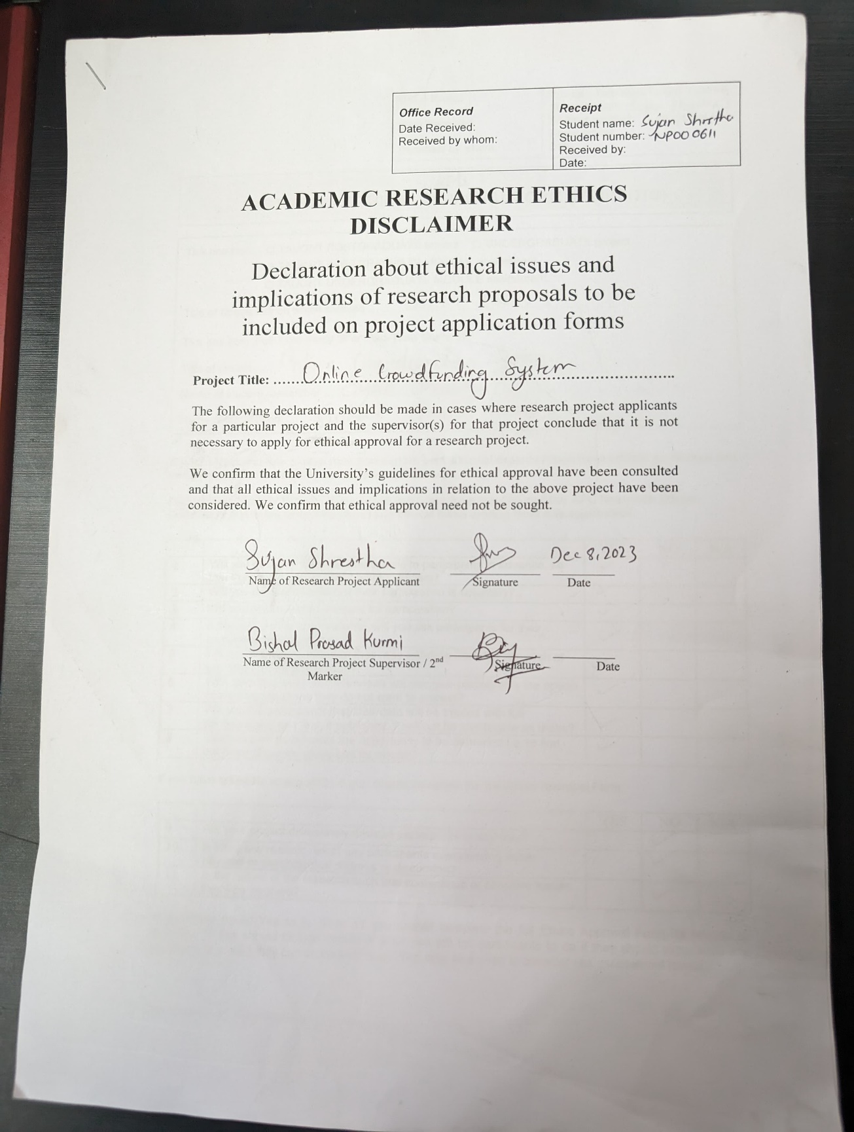

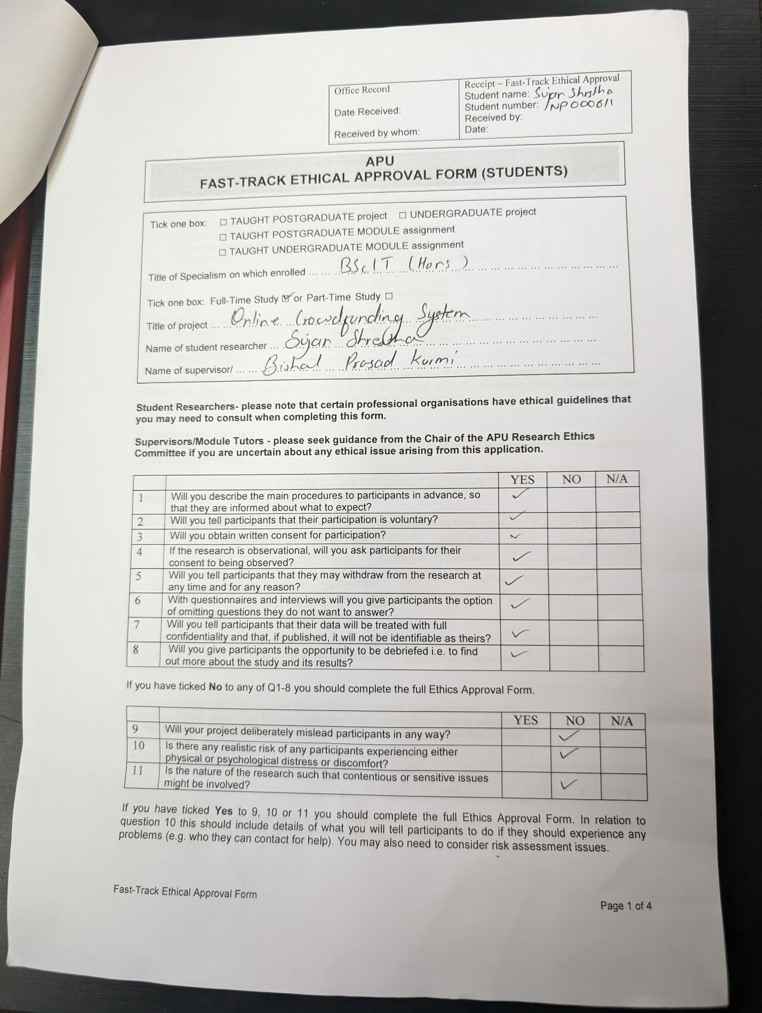

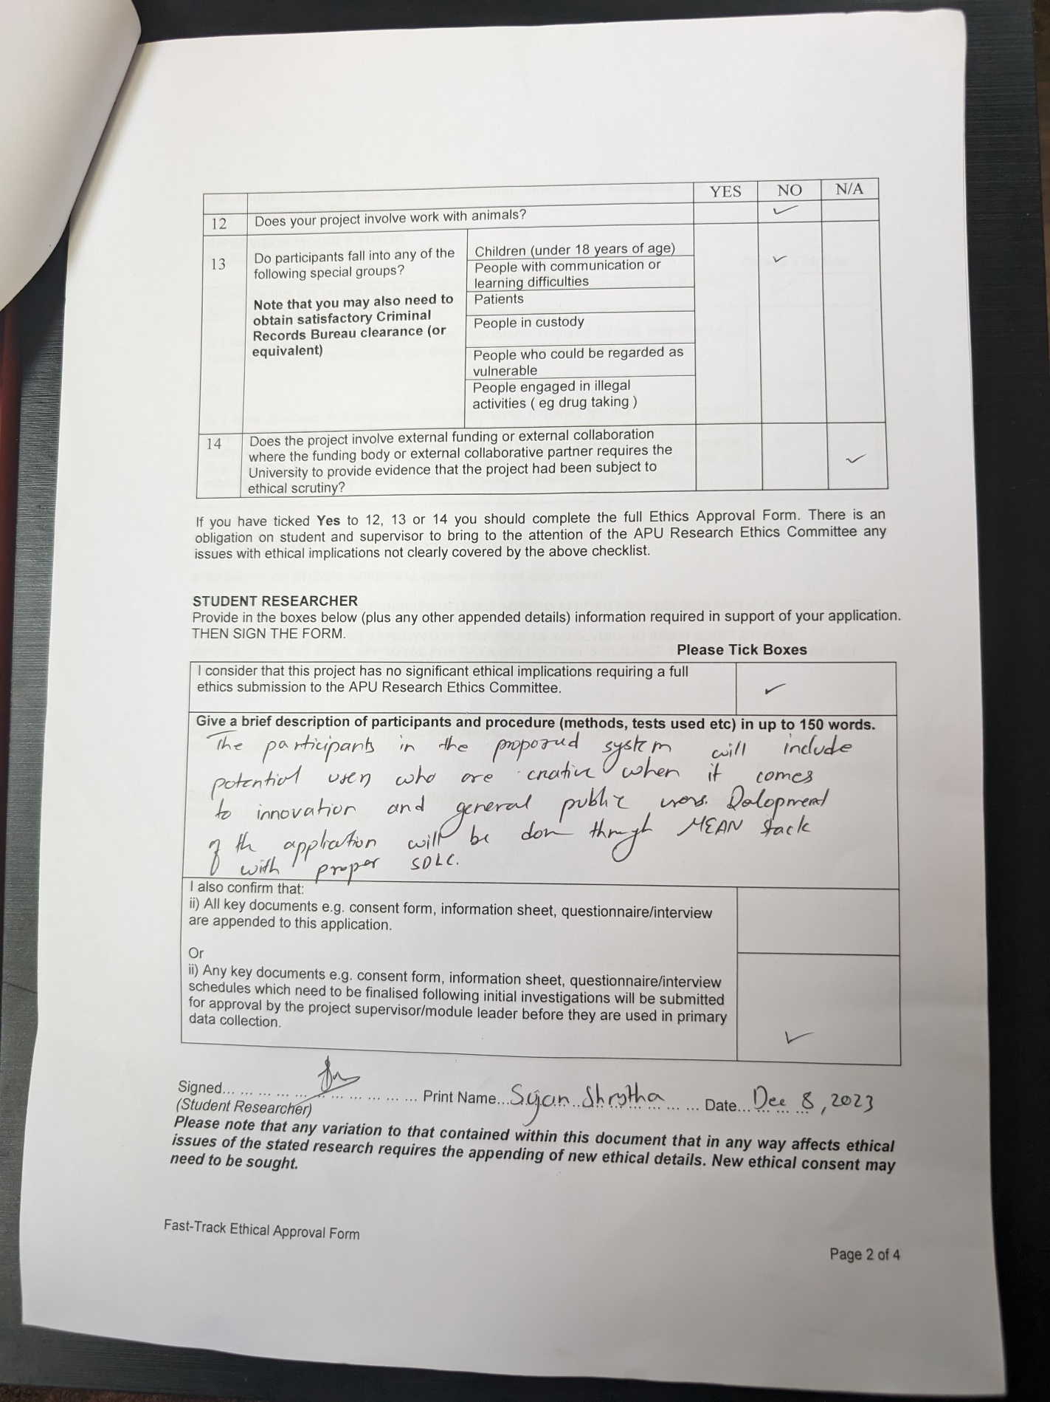

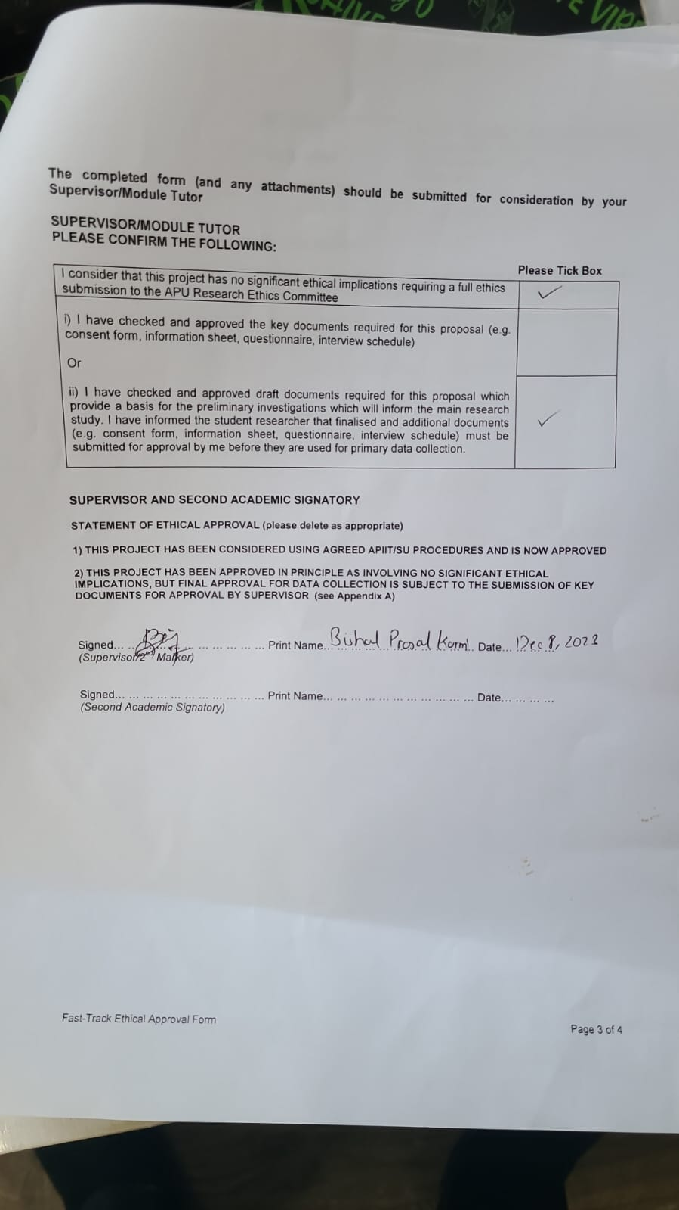

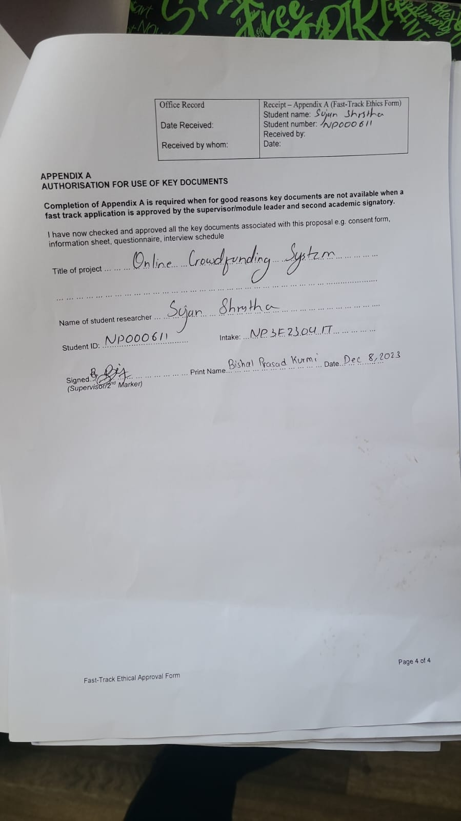

## Project Proposal Form (PPF)

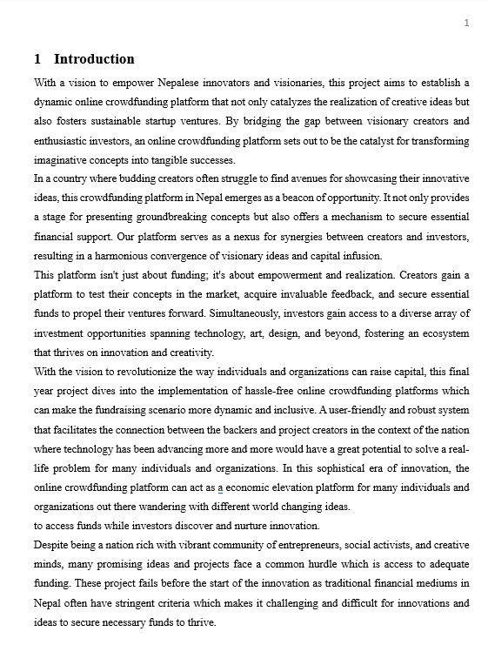

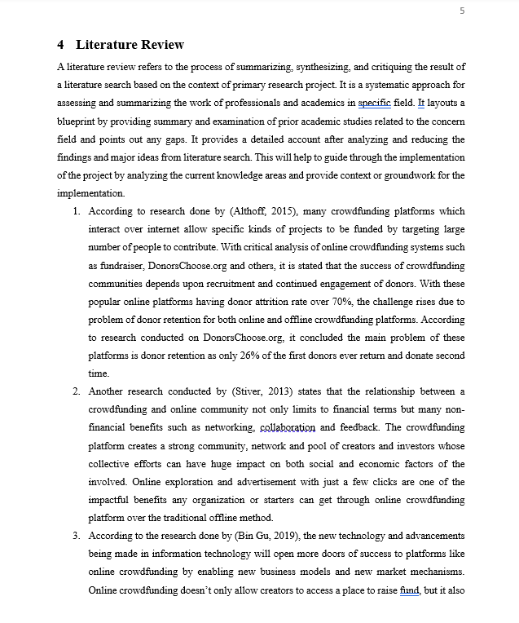

## Project Specification Form (PSF)

## Project Log Sheet



